|  |  |
| --- | --- |
| V.MANIVARMAN-TEAM LEAD | S.SARAN-TEAM MEMBER |

|  |  |
| --- | --- |
| M.SNEGA-TEAM MEMBER 2. | S.JEEVITHA-TEAM MEMBER 3. |

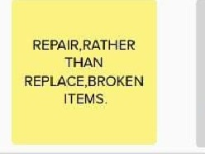BIOLOGICALLANDFILL

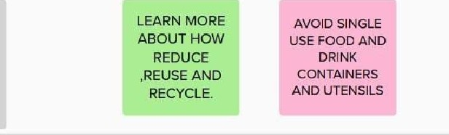

STOP

WASTING

ENERGY,

FOOD,MONEY

TREATMENTDISPOSAL

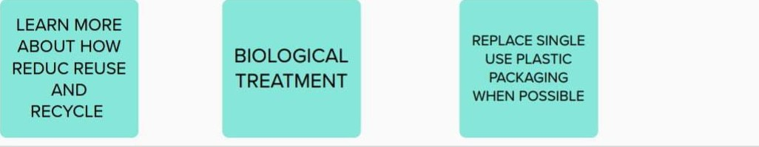OVER ALL IDEA- INTELLIGENT GARBAGE CLASSIFICATION USING DEEP LEARNING.

|  |  |  |  |  |
| --- | --- | --- | --- | --- |
|  | |  | | --- | | LANDFILL  DISPOSAL | | |  | | --- | | BUY USED CLOTHING AND HOUSE  HOLD ITEAM. | |